***RISSE Financial Resources (excerpt from work by Cassidy Layman, November 24, 2024)***

RISSE’s 2023 Impact Report shows a 60 percent increase in revenue from 2021 to 2023 (RISSE, 2024a, [Unpublished data]). The report also breaks down RISSE’s funding by source, as illustrated in Figure 1 (RISSE, 2024a, [Unpublished data]). Corporations and foundations were RISSE’s top two funding sources in 2023 and represent a combined 53.6 percent of the organization’s total revenue (RISSE, 2024a, [Unpublished data]). In 2022, foundations and corporate grants represented just 15.3 percent of the total revenue of U.S. nonprofits (Independent Sector, 2023). RISSE’s third-largest source of income was government funding, which represented 20.6 percent of revenue (RISSE, 2024a, [Unpublished data]). This is comparable to the 2022 national average of 19.4 percent (Independent Sector, 2023). While donations represented only 15.5 percent of RISSE’s revenue, they were the largest source of national nonprofit revenue at 32.1 percent (RISSE, 2024a, [Unpublished data]; Independent Sector, 2023). Absent from RISSE’s funding was program revenue, which made up 19.5 percent of nonprofit revenue nationally (RISSE, 2024a, [Unpublished data]; Independent Sector, 2023).

**Figure 1**

*Sources of RISSE Funding, 2023*

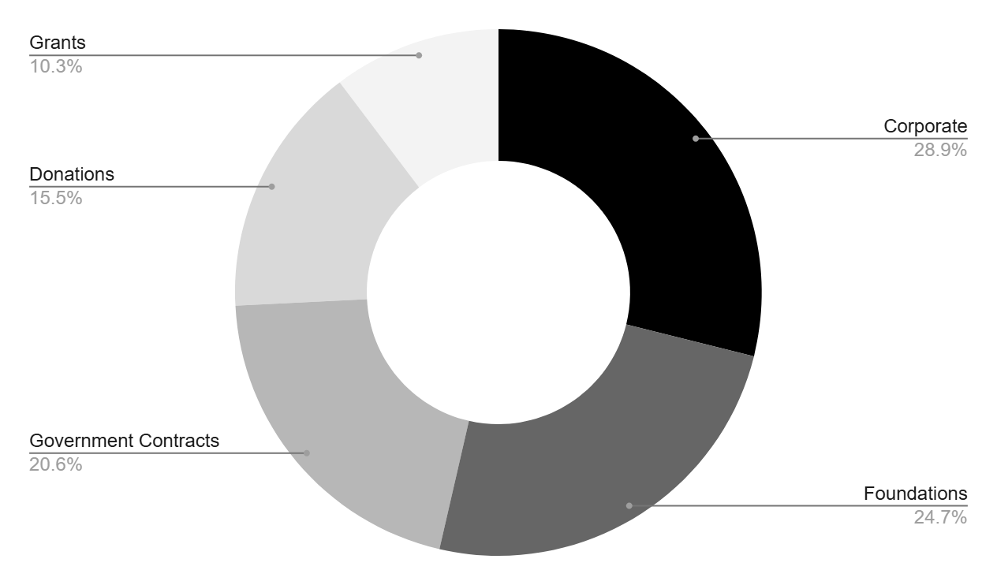

**References**

Independent Sector. (2023, November). *Health of the U.S. Nonprofit Sector: Annual Review.* <https://independentsector.org/wp-content/uploads/2023/11/2023-Health-of-the-U.S.-Nonprofit-Sector-Annual-Review.pdf>

Refugee and Immigrant Support Services of Emmaus. (n.d.-a). <https://www.risse-albany.org>

Refugee and Immigrant Support Services of Emmaus. (n.d.-b). About. <https://www.risse-albany.org/about>

Refugee and Immigrant Support Services of Emmaus. (n.d.-c). Meet the team. <https://www.risse-albany.org/meet-the-team>

Refugee and Immigrant Support Services of Emmaus. (2024a). 2023 impact report. Unpublished.